Week End Assignment

WEEK 0

ASSIGNMENT 4

PROGRAM:

using System;

using System.Collections.Generic;

using System.Linq;

using System.Text;

using System.Threading.Tasks;

namespace weekend1in13

{

class Program

{

static void Main(string[] args)

{

Start:

int v, V, w, h, H = 0, i = 0, j;

Console.Write("Enter the Volume of bowl:");

//validation of number input

String Result = Console.ReadLine();

while(!Int32.TryParse(Result,out V))

{

Console.Write("Enter a Valid number as Volume of BOWL:");

Result = Console.ReadLine();

}

Console.Write("Enter the Volume of water in bowl:");

Result = Console.ReadLine();

while (!Int32.TryParse(Result, out v))

{

Console.Write("Enter a Valid number as Volume of WATER:");

Result = Console.ReadLine();

}

//Check if given input produces a logical output

if (V > v)

{

while (true) //infinite loop and increse the height of BOWL

{

++H;

for (h = 0; h < H; ) //height of water should not exceed BOWL

{

h++;

//width calculation from user input volume

for (w = 1; h \* h + w \* h - h < v; ++w) ;

//condition for width match or Increase BOWL height

if (H \* H + w \* H - H == V)

{

while (H-- != 0)

{

++i;

for (int k = 0; k < i; k++)

if (k == (i - 1))

Console.Write((char)92);

else

Console.Write((char)32);

//filling the BOWL with space,ciddle or underscore using ascii value

for (j = 0; j < (w - 1 + 2 \* H); ) //As H decreases the space reduces and converges

{

j++;

Console.Write(H > 0 ? (H == h ? (char)126 : (char)32) : (char)95);

}

Console.WriteLine((char)47);

}

goto End; //loop break after print

}

}

}

}

else

{

Console.WriteLine("Enter the volume of water less than bowl");

goto Start;

}

End:

Console.WriteLine("If you want to continue enter 1:");

string ret="";

ret=Console.ReadLine();

if(ret=="1")

{

goto Start;

}

else

{

Console.WriteLine("Press Enter to exit");

}

Console.ReadKey();

}

}

}

ALGORITHM:

1. Get the volumes and Validate them for providing logical output
2. Increment the height of BOWL first then the WATER depending on the match in width of the two which could produce an output
3. If the width matches for both bowl and water the condition becomes feasible
4. Start printing from top and decrement height of BOWL
5. Filling the BOWL with space water or base is depending on the height match between BOWL, WATER and ZERO
6. Print the other side of bowl
7. End of Program.

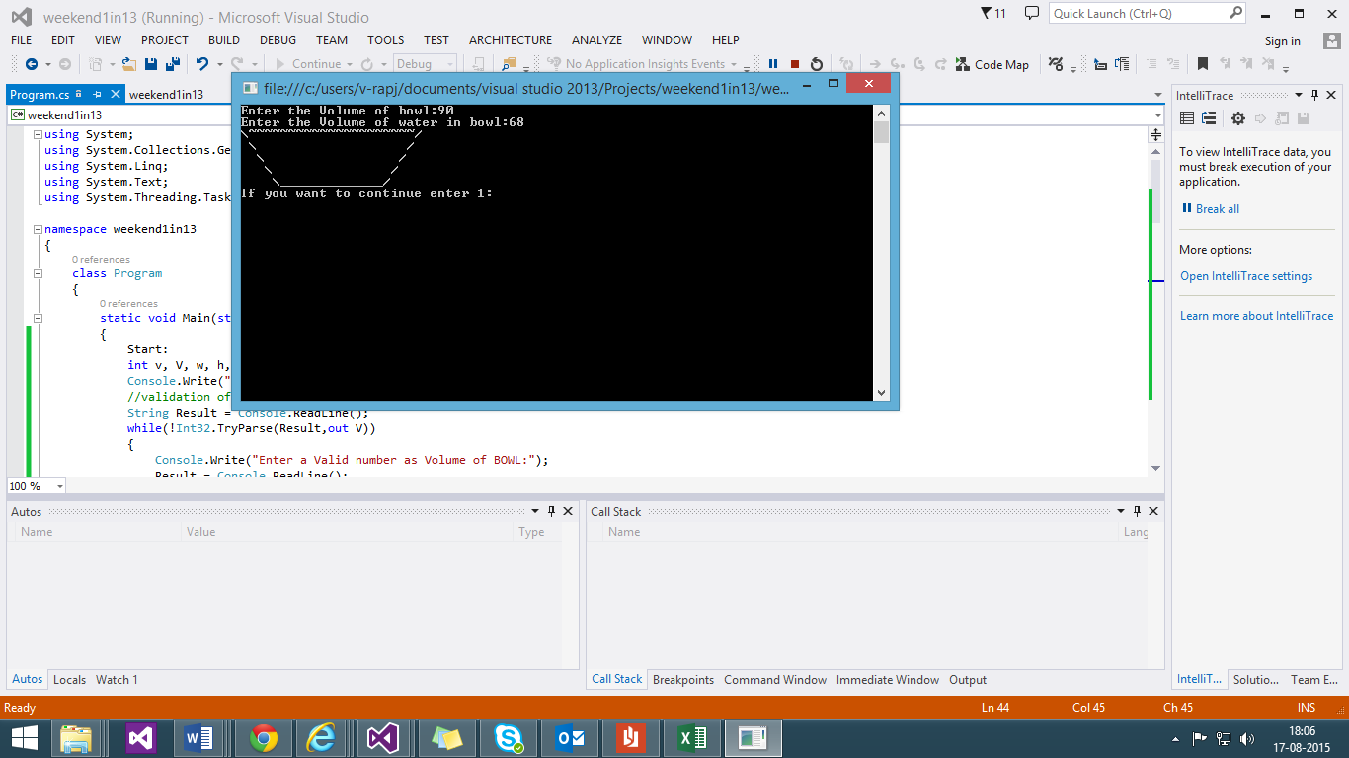

YES

Other side closing of the BOWL is printed as WriteLine

Print inside of bowl using a loop

Print ‘\’ and space using for loop and if

NO

STOP

H--!=0

Do w++

If

Width w

Fits both

volume

NO

YES

Height of BOWL H and Height of Water h is incremented

NO

If

V>v

Get the BOWL Volume V and the water v from user

START